Azure Firewall
https://youtu.be/Bx94L5jZxTo
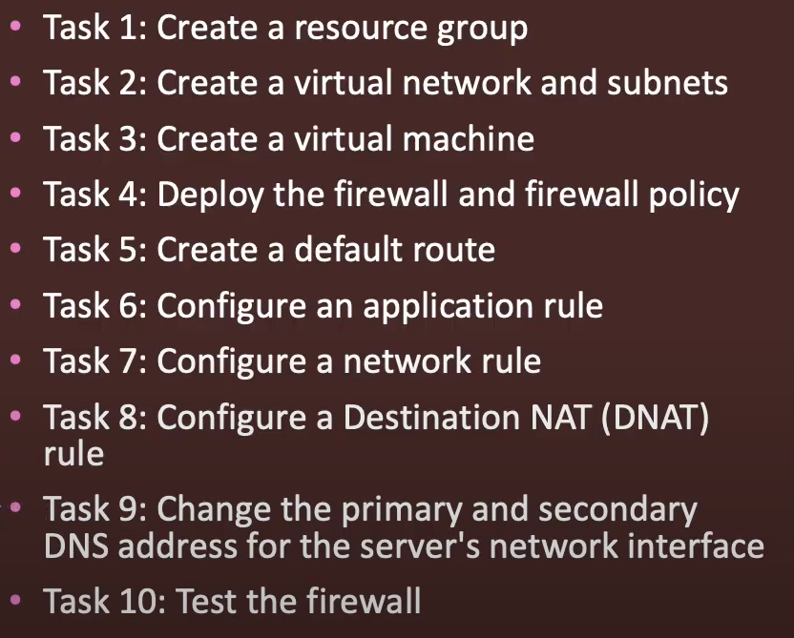

🔥 What is Azure Firewall?
Azure Firewall is a cloud-native, managed network security service that protects Azure Virtual Network (VNet) resources. It acts as a stateful firewall as a service, filtering traffic between Azure VNets and the internet or on-premises.

🧱 Key Features of Azure Firewall
1. Stateful Inspection
- Remembers the state of active connections.
- Analyzes traffic packets for malicious content and context.
2. Built-in High Availability
- High availability is included by default across Availability Zones (Zone-redundant deployment is optional).
3. Fully Managed by Microsoft
- Microsoft handles scaling, patching, and maintenance.
4. Threat Intelligence
- Integrates with Microsoft Threat Intelligence to alert or deny traffic from known malicious IPs/domains.
5. FQDN Filtering
- Allows or blocks traffic based on fully qualified domain names.
6. Network and Application Rules
- Define access based on IPs, ports, protocols (network rules), or URLs (application rules).
7. Logging and Monitoring
- Integrated with Azure Monitor, Log Analytics, and Event Hubs.

🔐 Types of Azure Firewalls
Type | Description
Azure Firewall Standard | Basic version with essential features like stateful inspection, rules, and logging.
Azure Firewall Premium | Advanced version that includes TLS inspection, IDPS (intrusion detection/prevention), and URL filtering.

🧰 Components of Azure Firewall
Component | Purpose
Firewall Policy | Centralized rule management across multiple firewalls.
Application Rules | Filter traffic based on FQDNs, domains, and web categories.
Network Rules | Filter traffic based on IP addresses, protocols, and ports.
NAT Rules | Used to translate and forward incoming traffic to private IPs.
Threat Intelligence | Block/alert traffic based on Microsoft’s threat intel.

Azure Firewall is a cloud-native firewall service that provides highly available, scalable protection for your resources in Azure Virtual Networks.
Azure Firewall provides stateful filtering, meaning it tracks the state of network connections and allows or blocks traffic based on that state.
Multi-Layer Security: It works at both Layer 3 (network) and Layer 7 (application), providing detailed traffic filtering.

- Deployment Scenarios
- Hub-and-Spoke Architecture
  - Azure Firewall is placed in the hub VNet.
  - Spoke VNets route their traffic through the hub using User Defined Routes (UDRs).
- Forced Tunneling
  - You can send all traffic to on-prem via VPN/ExpressRoute — not supported directly by Azure Firewall unless internet connectivity is preserved using 0.0.0.0/0 UDR to Internet.
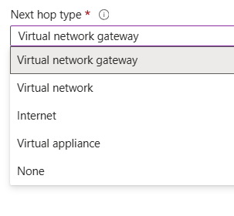

📌 Important Notes
- Public IP is mandatory for Azure Firewall to connect to the internet.
- Works only with Azure VNets, not on-prem directly.
- Firewall must be deployed in a dedicated subnet named AzureFirewallSubnet.

💵 Pricing
Azure Firewall is priced based on:
- Deployment per hour.
- Data processed per GB.
- Premium adds more costs due to advanced features.
👉 Pricing page: Azure Firewall Pricing

